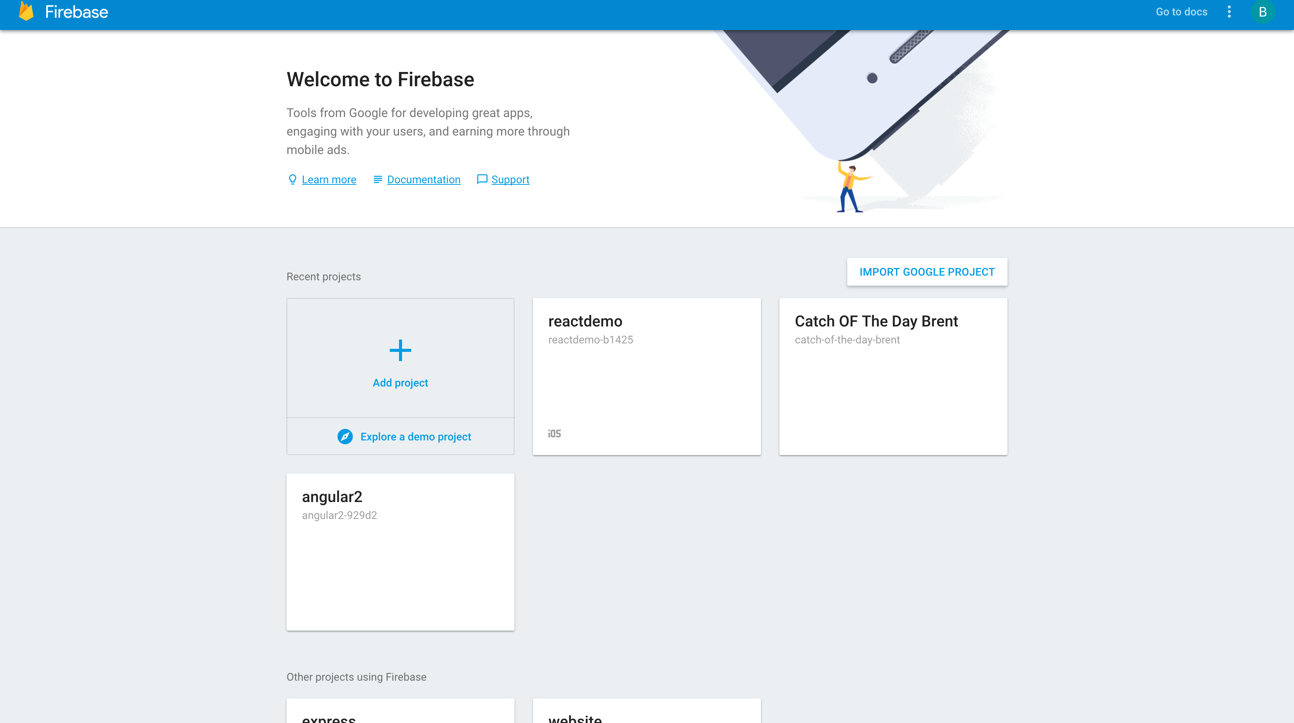

create new project in firebase

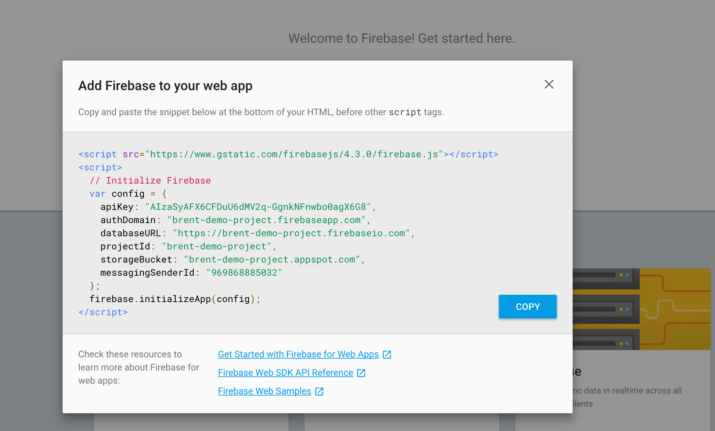

click add fire base to your webproject, copy apikey, authDomain, databaseURL

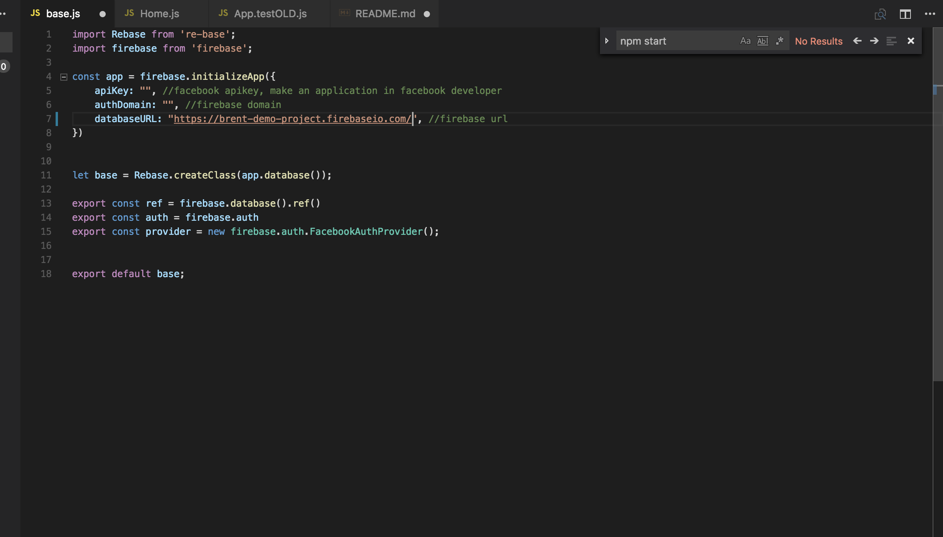

paste them in base.js

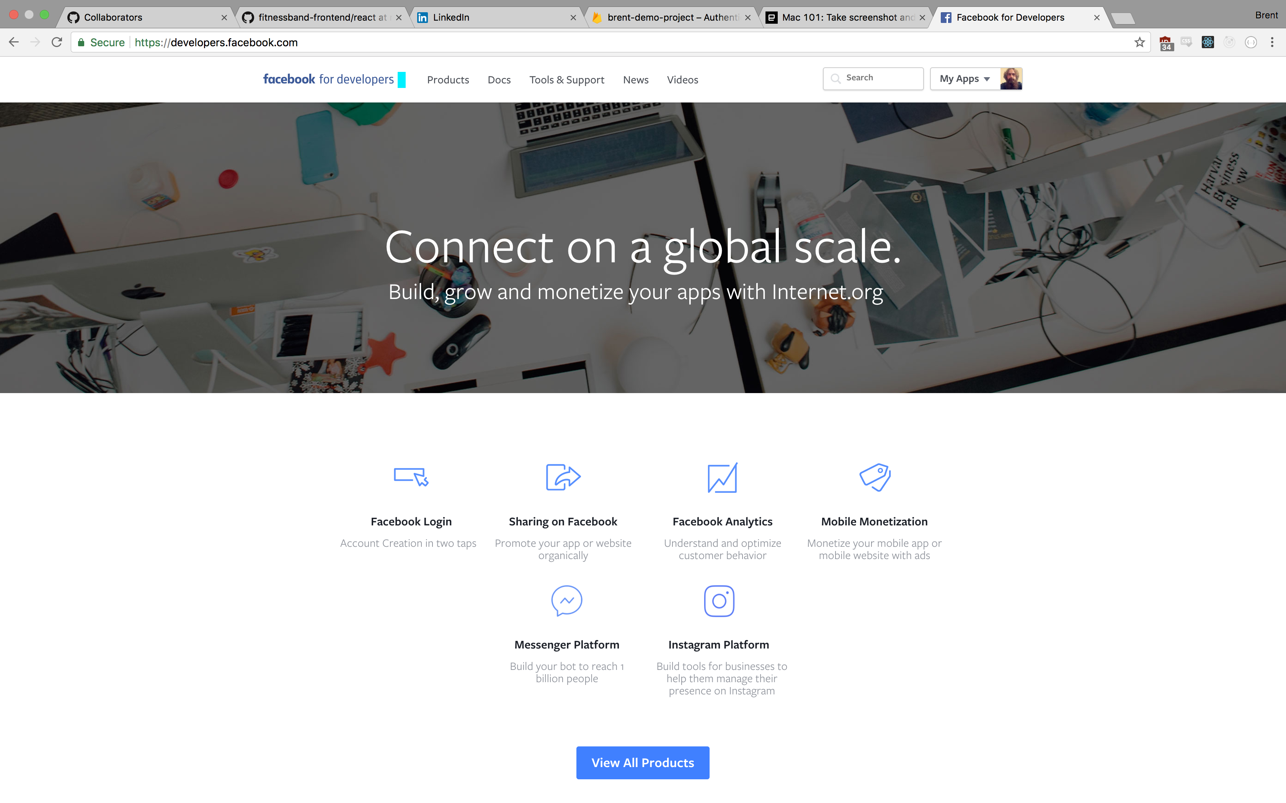

create a new application in facebook through developers.facebook.com

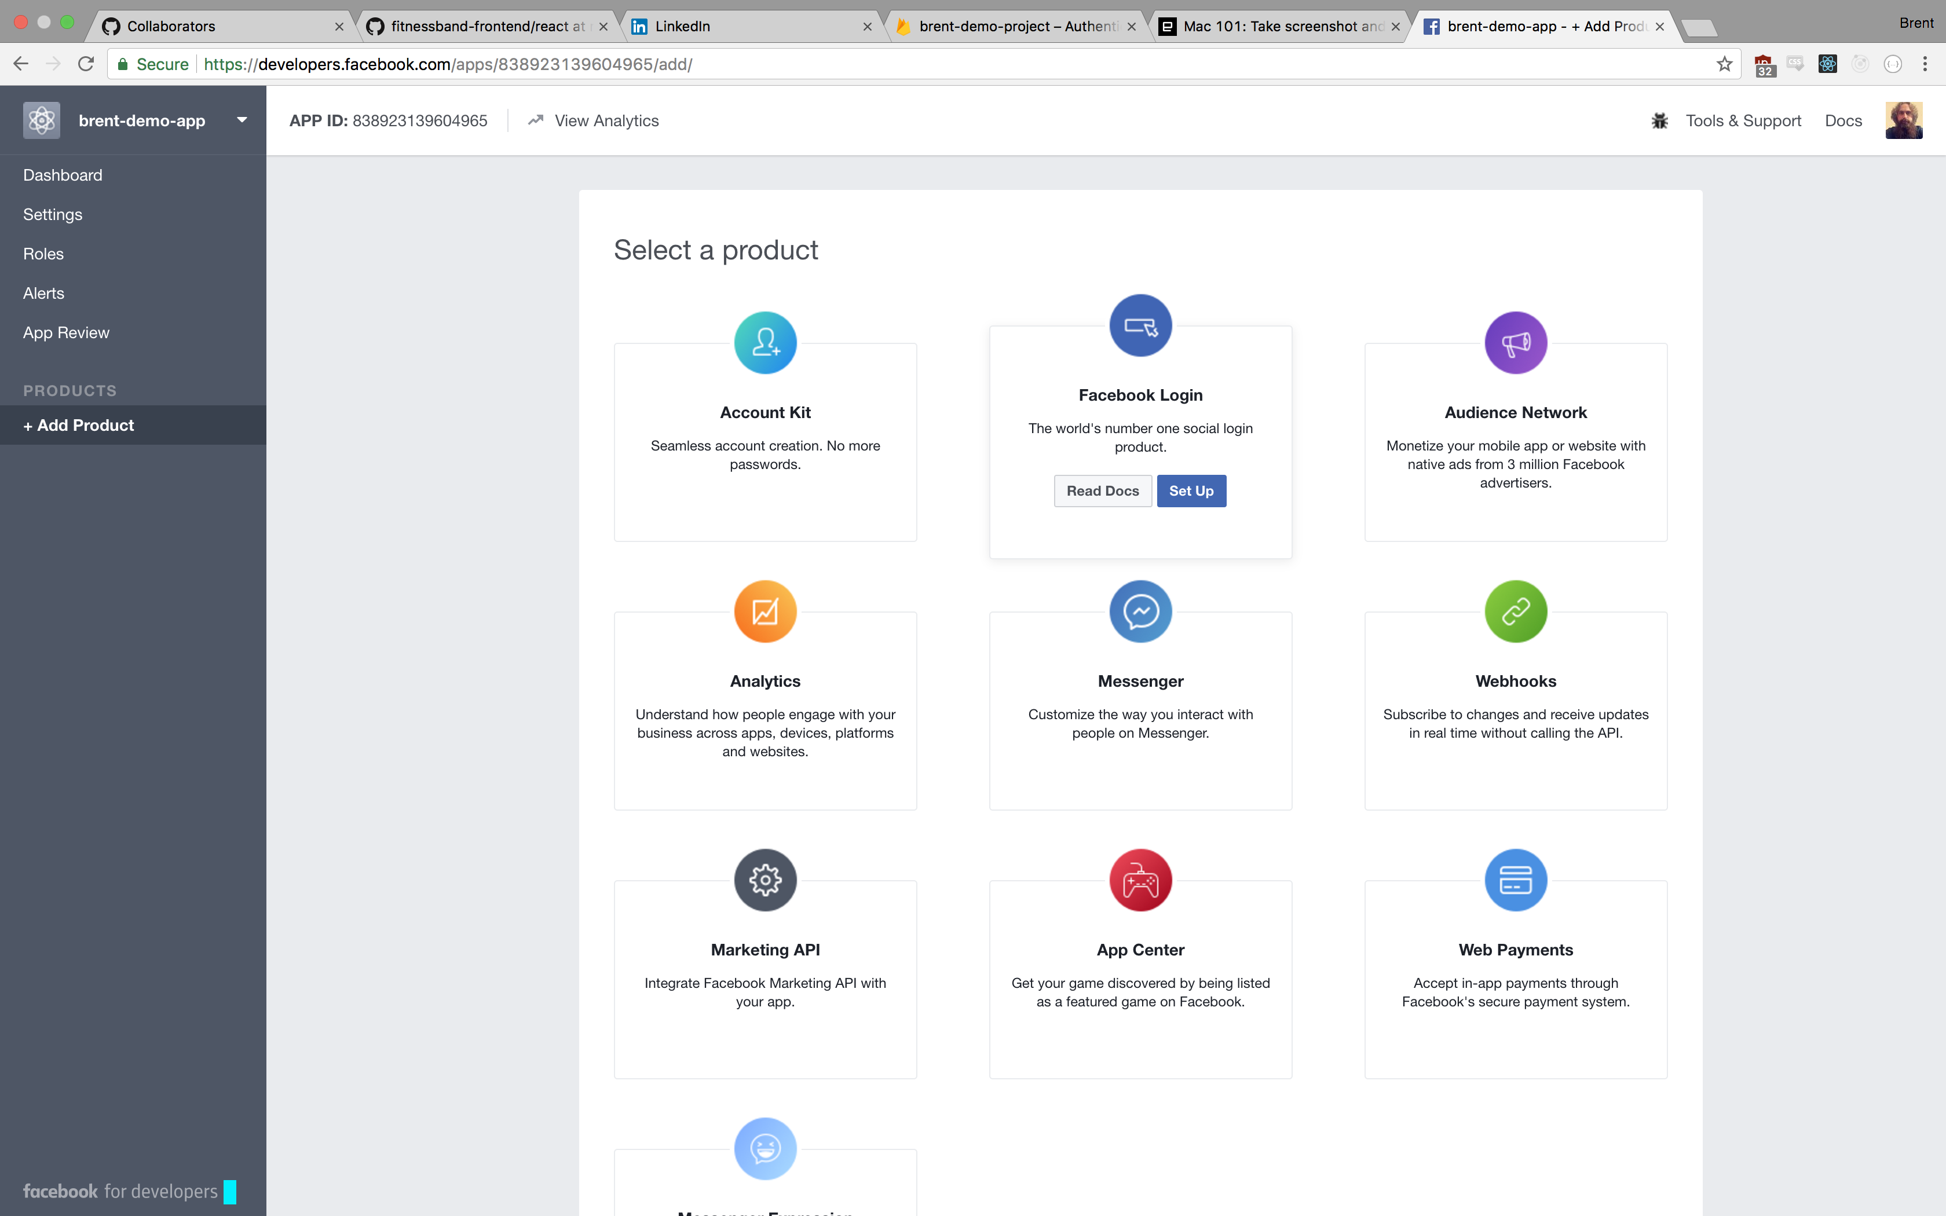

facebook login

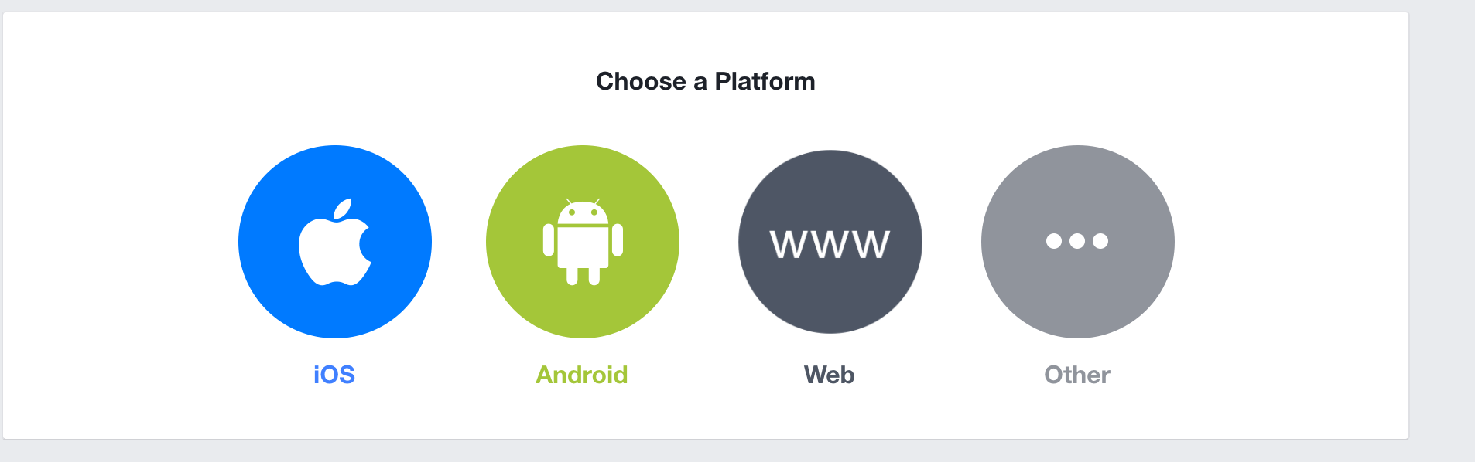

web platform

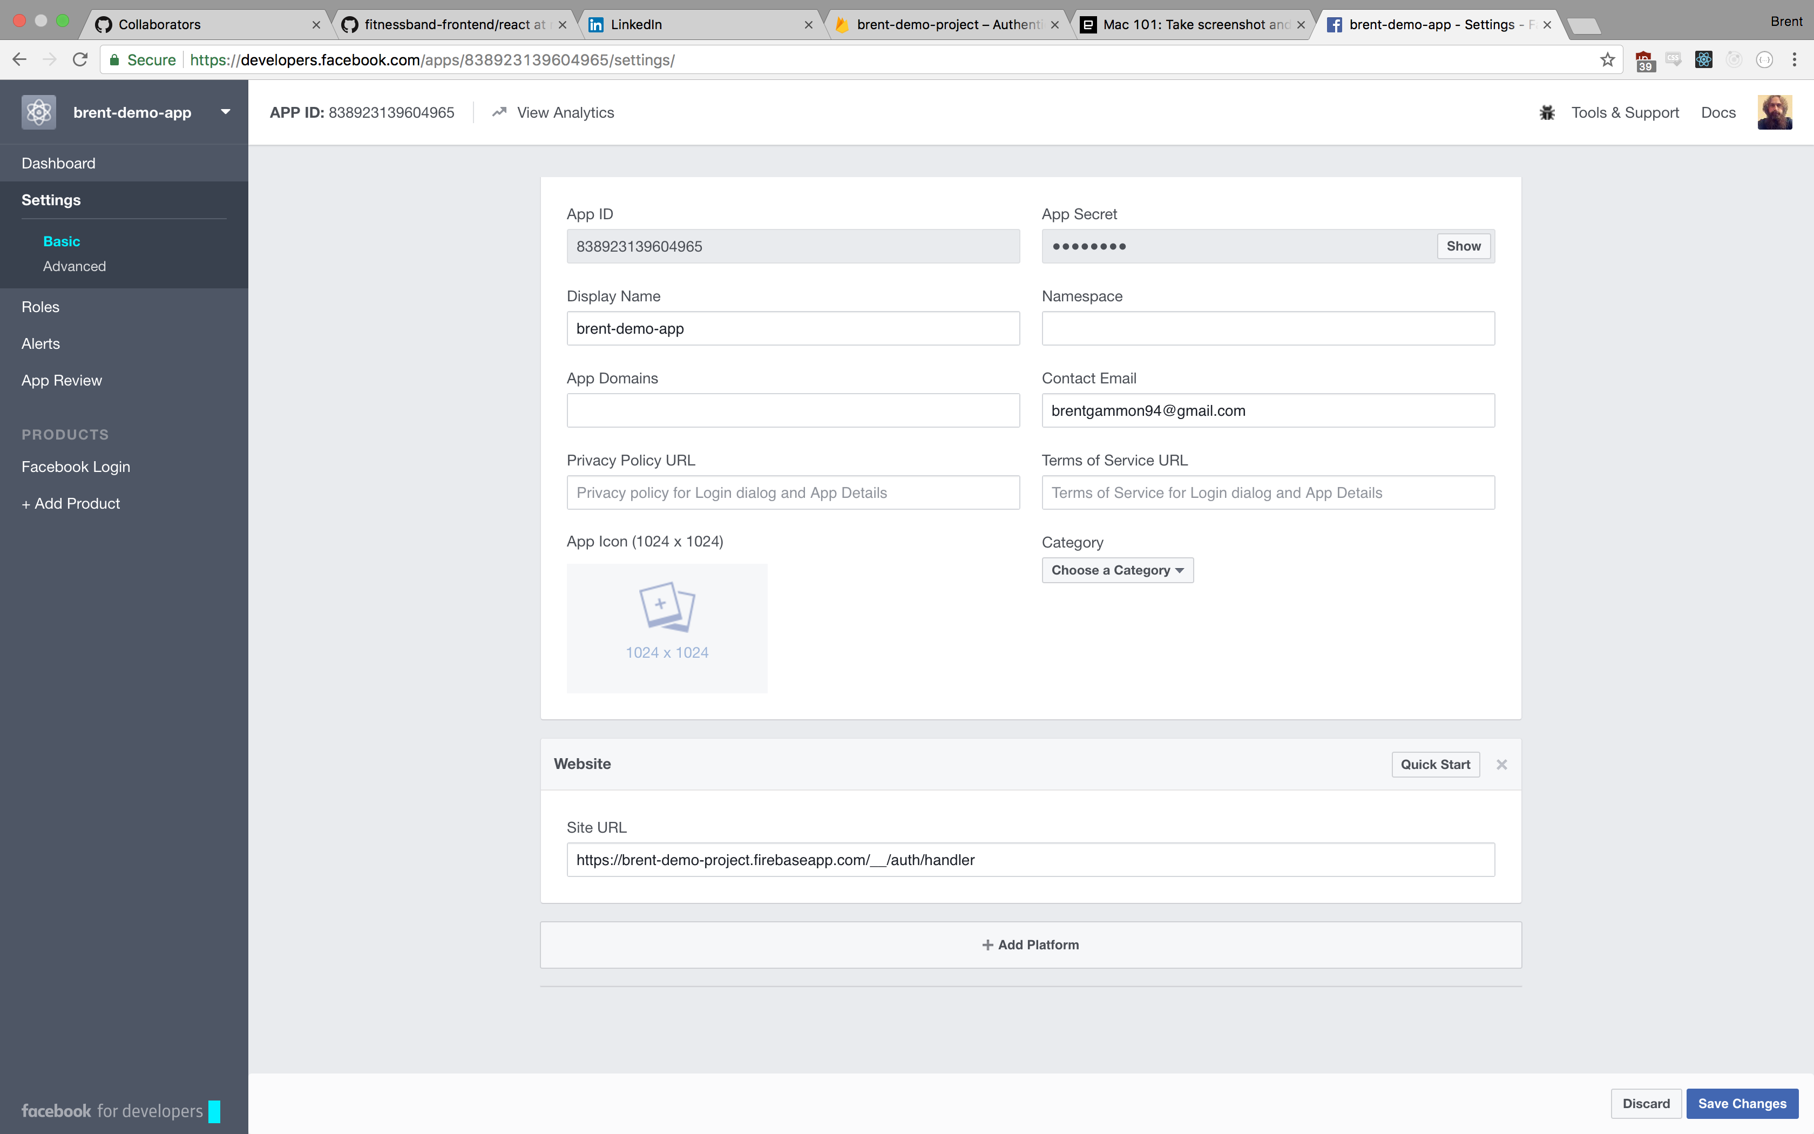

copy app id and app secret

oAuth redirect URI, copy and paste into site URL in the a image above

